JAVA SWING BASED –COGNITIVE DISORDERS - SQL CONNECTIVITY USING JDBC

A
Report
Submitted in partial fulfillment of the
Requirements for the award of the Degree of

BACHELOR OF ENGINEERING IN
INFORMATION TECHNOLOGY
By

Shyam Prasad <1602-20-737-042>
Under the guidance of Ms B. Leelavathy



Department of Information Technology Vasavi College of Engineering (Autonomous) (Affiliated to Osmania University) Ibrahimbagh, Hyderabad-31

2020-2021

BONAFIDE CERTIFICATE

This is to certify that this project report titled
‘COGNITIVE DISORDERS’
is a project work of Shyam bearing
roll no. 1602-20-737-042 who carried out this project under my supervision in the IV semester for the academic year 2021- 2022

Signature Signature
External Examiner Internal Examiner

ABSTRACT

In Recording the symptoms of senior citizens. The health information was stored using database. And service been provided to that according to precautions and medicines. And all the medicines which are used to which disease was stored in the tables . That information also stored in it.

Requirement Analysis

List of Tables:
- Citizens
- sick
- illness
- cure
- medicine
-Billing

List of Attributes with their Domain Types:

Citizens_M

* name varchar2(20),
*sid number,
* sage number,
*sgender varchar2(10),
* primary key(sid));

Illness
*illness_id number(15),
*symptoms varchar(20)
*since date

medicine

* medicine_ID number(10),
*generic_name varchar2(25),
* purpose varchar2(20),
*precuations varchar(20));

sick

sid number,
illness_ID number(10),
since date,
foreign key(sid) references Student_M,
foreign key(illness_ID) references illness,
primary key(sid,illness_ID));

billing

bill_no number(10),
sid number,
foreign key(bill_no) references bill,
foreign key(sid) references Citizens_M,
primary key(bill_no,sid));

AIM AND PRIORITY OF THE PROJECT

To create a Java GUI-based desktop application that connects students looking for internships with project managers looking for interns. It takes values like citizen name, citizen id, gender, symptoms, etc through forms which are then updated in the database using JDBC connectivity.

ARCHITECTURE AND TECHNOLOGY

Software used:
Java Eclipse, Oracle 11g Database, Java SE version 13, SQL*Plus.

Java SWING:
Java SWING is a GUI widget toolkit for Java. It is part of Oracle's Java Foundation Classes (JFC) - an API for providing a graphical user interface (GUI) for Java programs.

Swing was developed to provide a more sophisticated set of GUI components than the earlier AWT. Swing provides a look and feel that emulates the look and feel of several platforms, and also supports a pluggable look and feel that allows applications to have a look and feel unrelated to the underlying platform. It has more powerful and flexible components than AWT. In addition to familiar components such as buttons, check boxes and labels, Swing provides several advanced components such as tabbed panel, scroll panes, trees, tables, and lists.

SQL:
Structure Query Language(SQL) is a database query language used for storing and managing data in Relational DBMS. SQL was the first commercial language introduced for E.F Codd's Relational model of database. Today almost all RDBMS (MySql, Oracle, Infomix, Sybase, MS Access) use SQL as the standard database query language. SQL is used to perform all types of data operations in RDBMS.

DESIGN

Entity Relationship Diagram

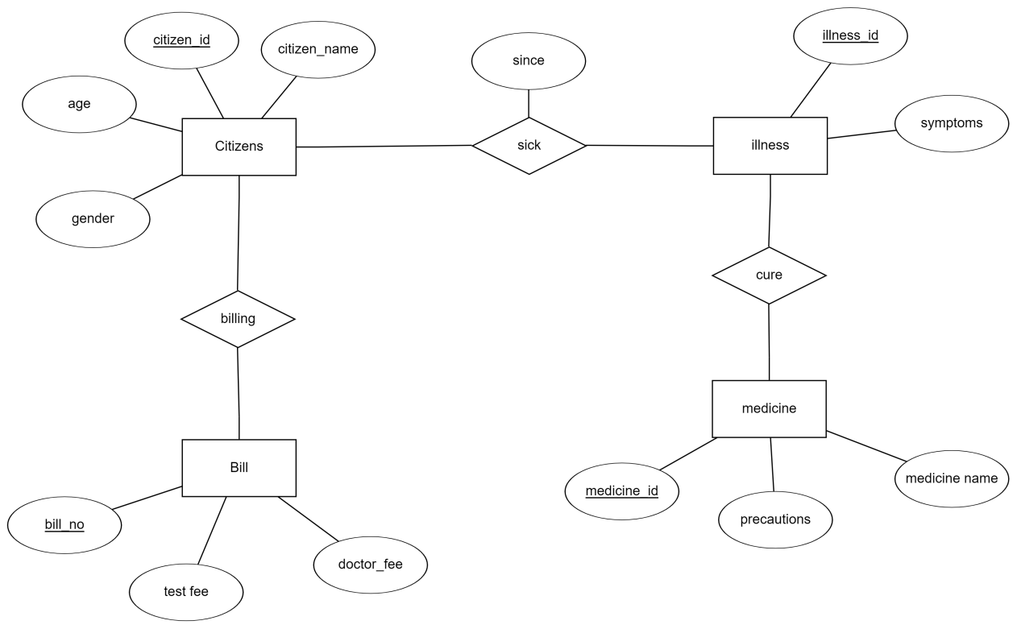

DATABASE DESIGN

Mapping Cardinality and Participation Constraints

The symptoms of citizens will be taken and according to the symptoms they have will given so precautions are given to control
the mental health.
The database of citizens and illness have a relational set. And between illness and medicine there is a relational set consultation.
In which if there is need to consult doctor id is provided.
And there is a relational set between citizen and bill. In billing relational set there are bills by doctor , medicine ,tests fee.

DDL Operations

SQL> create table Citizen (cit_id number primary key,name varchar(20),age number,gender varchar(5));

Table created.

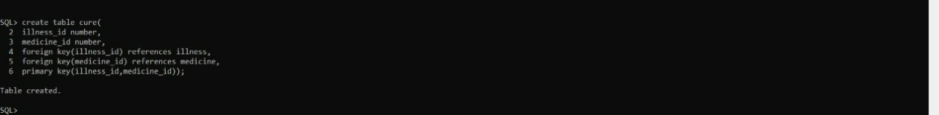

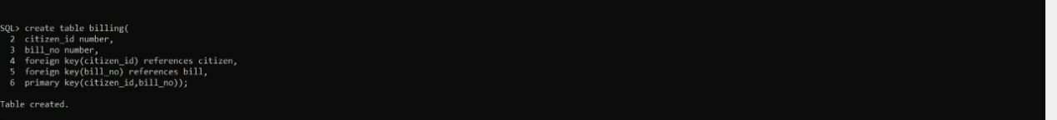

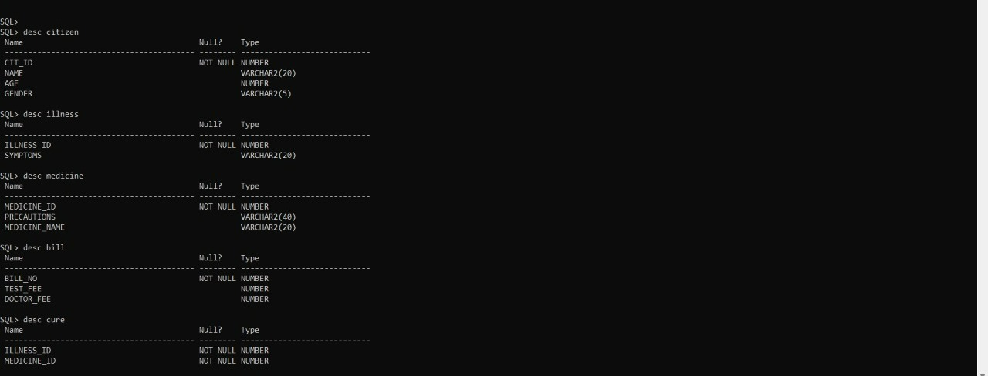

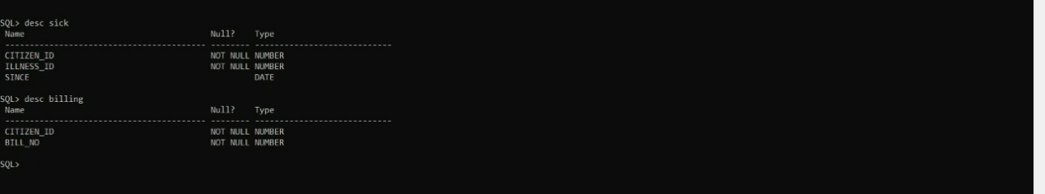

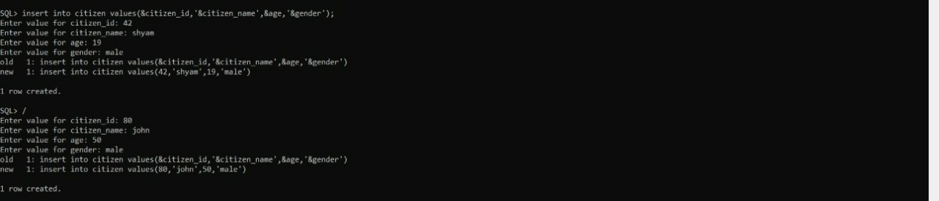

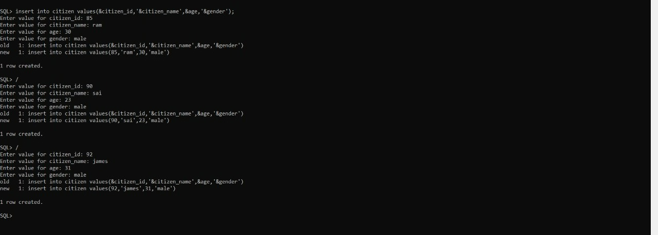

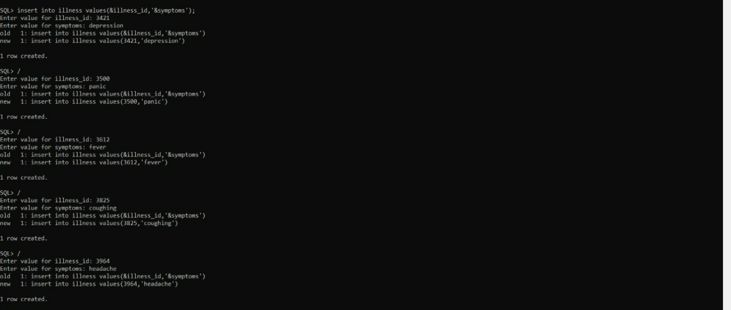

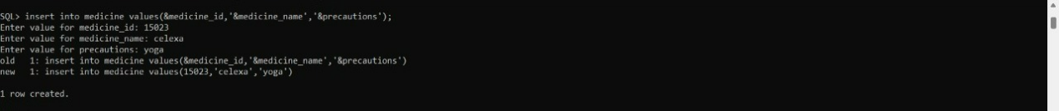

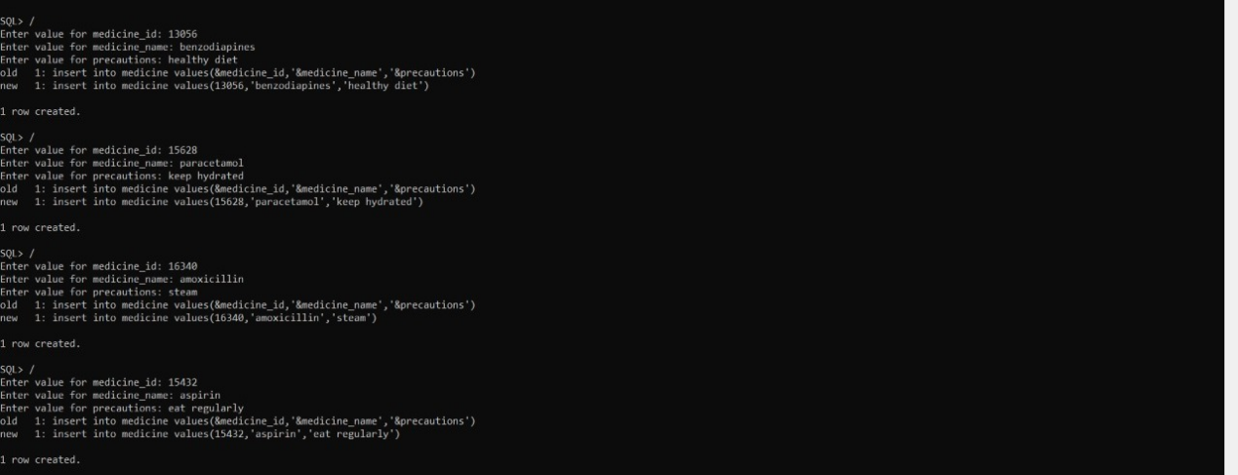

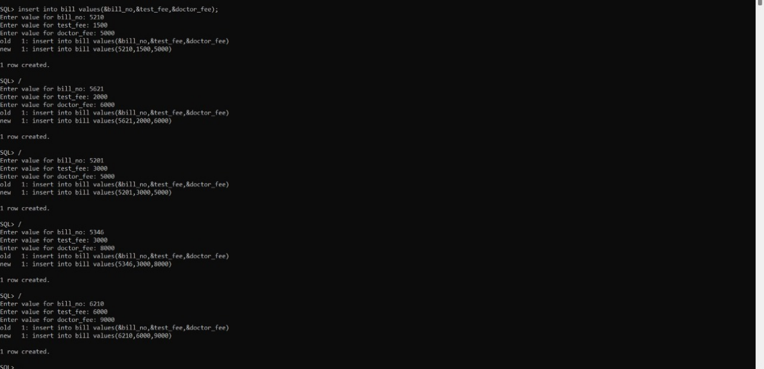

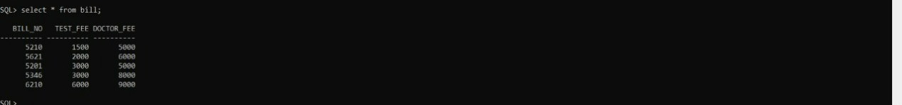

IMPLEMENTATION:
Program:
MainPage:

public class mainpage extends javax.swing.JFrame {

/**
* Creates new form mainpage
*/
public mainpage() { initComponents();
}

/**
- This method is called from within the constructor to initialize the form.
- WARNING: Do NOT modify this code. The content of this method is always
- regenerated by the Form Editor.
*/ @SuppressWarnings("unchecked")
// <editor-fold defaultstate="collapsed" desc="Generated Code"> private void initComponents() {

jMenuBar2 = new javax.swing.JMenuBar(); jMenu3 = new javax.swing.JMenu(); jMenu4 = new javax.swing.JMenu(); jMenuBar3 = new javax.swing.JMenuBar(); jMenu5 = new javax.swing.JMenu(); jMenu6 = new javax.swing.JMenu(); jMenu8 = new javax.swing.JMenu();
jComboBox1 = new javax.swing.JComboBox<>(); jLabel1 = new javax.swing.JLabel();
jLabel2 = new javax.swing.JLabel(); jMenuBar1 = new javax.swing.JMenuBar(); jMenu1 = new javax.swing.JMenu();
jCheckBoxMenuItem1 = new javax.swing.JCheckBoxMenuItem(); jMenuItem1 = new javax.swing.JMenuItem();
jMenuItem2 = new javax.swing.JMenuItem();
jMenuItem3 = new javax.swing.JMenuItem(); jMenu2 = new javax.swing.JMenu(); jMenu13 = new javax.swing.JMenu(); jMenuItem4 = new javax.swing.JMenuItem(); jMenuItem5 = new javax.swing.JMenuItem(); jMenuItem6 = new javax.swing.JMenuItem(); jMenu7 = new javax.swing.JMenu(); jMenuItem7 = new javax.swing.JMenuItem(); jMenuItem8 = new javax.swing.JMenuItem(); jMenuItem9 = new javax.swing.JMenuItem();
jMenuItem10 = new javax.swing.JMenuItem(); jMenu9 = new javax.swing.JMenu(); jMenuItem12 = new javax.swing.JMenuItem(); jMenuItem11 = new javax.swing.JMenuItem(); jMenuItem13 = new javax.swing.JMenuItem(); jMenu10 = new javax.swing.JMenu(); jMenuItem14 = new javax.swing.JMenuItem(); jMenuItem15 = new javax.swing.JMenuItem(); jMenuItem16 = new javax.swing.JMenuItem(); jMenuItem17 = new javax.swing.JMenuItem(); jMenu11 = new javax.swing.JMenu(); jMenuItem18 = new javax.swing.JMenuItem(); jMenuItem19 = new javax.swing.JMenuItem(); jMenuItem20 = new javax.swing.JMenuItem(); jMenuItem24 = new javax.swing.JMenuItem(); jMenu12 = new javax.swing.JMenu(); jMenuItem21 = new javax.swing.JMenuItem(); jMenuItem22 = new javax.swing.JMenuItem(); jMenuItem23 = new javax.swing.JMenuItem(); jMenuItem25 = new javax.swing.JMenuItem();

jMenu3.setText("File"); jMenuBar2.add(jMenu3);

jMenu4.setText("Edit"); jMenuBar2.add(jMenu4);

jMenu5.setText("File");
jMenuBar3.add(jMenu5);

jMenu6.setText("Edit"); jMenuBar3.add(jMenu6);
jMenu8.setText("jMenu8"); jComboBox1.setModel(new
javax.swing.DefaultComboBoxModel<>(new String[] { "Item 1", "Item 2",
"Item 3", "Item 4" }));

setDefaultCloseOperation(javax.swing.WindowConstants.EXIT_ON_CLOS E);

jLabel2.setIcon(new javax.swing.ImageIcon(getClass().getResource("/pic1.jpeg"))); // NOI18N

jMenu1.setText("medicine");

jCheckBoxMenuItem1.setSelected(true); jCheckBoxMenuItem1.setText("insert"); jCheckBoxMenuItem1.addActionListener(new
java.awt.event.ActionListener() {
public void actionPerformed(java.awt.event.ActionEvent evt) { jCheckBoxMenuItem1ActionPerformed(evt);
}
});
jMenu1.add(jCheckBoxMenuItem1);

jMenuItem1.setText("delete");
jMenuItem1.addActionListener(new java.awt.event.ActionListener() { public void actionPerformed(java.awt.event.ActionEvent evt) {
jMenuItem1ActionPerformed(evt);
}
});
jMenu1.add(jMenuItem1);

jMenuItem2.setText("update");
jMenuItem2.addActionListener(new java.awt.event.ActionListener() {
26

public void actionPerformed(java.awt.event.ActionEvent evt) { jMenuItem2ActionPerformed(evt);
}
});
jMenu1.add(jMenuItem2);

jMenuItem3.setText("view");
jMenuItem3.addActionListener(new java.awt.event.ActionListener() { public void actionPerformed(java.awt.event.ActionEvent evt) {
jMenuItem3ActionPerformed(evt);
}
});
jMenu1.add(jMenuItem3); jMenuBar1.add(jMenu1); jMenu2.setText("student");
jMenu13.setText("insert");
jMenu13.addActionListener(new java.awt.event.ActionListener() { public void actionPerformed(java.awt.event.ActionEvent evt) {
jMenu13ActionPerformed(evt);
}
});
jMenu2.add(jMenu13);

jMenuItem4.setText("delete");
jMenuItem4.addActionListener(new java.awt.event.ActionListener() { public void actionPerformed(java.awt.event.ActionEvent evt) {
jMenuItem4ActionPerformed(evt);
}
});
jMenu2.add(jMenuItem4);

jMenuItem5.setText("update");
jMenuItem5.addActionListener(new java.awt.event.ActionListener() { public void actionPerformed(java.awt.event.ActionEvent evt) {
jMenuItem5ActionPerformed(evt);

}
});
jMenu2.add(jMenuItem5);

jMenuItem6.setText("view"); jMenu2.add(jMenuItem6);

jMenuBar1.add(jMenu2); jMenu7.setText("bill");
jMenuItem7.setText("insert");
jMenuItem7.addActionListener(new java.awt.event.ActionListener() { public void actionPerformed(java.awt.event.ActionEvent evt) {
jMenuItem7ActionPerformed(evt);
}
});
jMenu7.add(jMenuItem7);

jMenuItem8.setText("delete");
jMenuItem8.addActionListener(new java.awt.event.ActionListener() { public void actionPerformed(java.awt.event.ActionEvent evt) {
jMenuItem8ActionPerformed(evt);
}
});
jMenu7.add(jMenuItem8);

jMenuItem9.setText("update");
jMenuItem9.addActionListener(new java.awt.event.ActionListener() { public void actionPerformed(java.awt.event.ActionEvent evt) {
jMenuItem9ActionPerformed(evt);
}
});
jMenu7.add(jMenuItem9);

jMenuItem10.setText("view"); jMenu7.add(jMenuItem10);

jMenuBar1.add(jMenu7);

jMenu9.setText("consultation");

jMenuItem12.setText("insert"); jMenu9.add(jMenuItem12);

jMenuItem11.setText("delete"); jMenu9.add(jMenuItem11);

jMenuItem13.setText("view"); jMenu9.add(jMenuItem13);

jMenuBar1.add(jMenu9); jMenu10.setText("illness");
jMenuItem14.setText("insert");
jMenuItem14.addActionListener(new java.awt.event.ActionListener() { public void actionPerformed(java.awt.event.ActionEvent evt) {
jMenuItem14ActionPerformed(evt);
}
});
jMenu10.add(jMenuItem14);

jMenuItem15.setText("delete"); jMenu10.add(jMenuItem15);

jMenuItem16.setText("update"); jMenu10.add(jMenuItem16);

jMenuItem17.setText("view");
jMenuItem17.addActionListener(new java.awt.event.ActionListener() { public void actionPerformed(java.awt.event.ActionEvent evt) {
jMenuItem17ActionPerformed(evt);
}
});
jMenu10.add(jMenuItem17);

jMenuBar1.add(jMenu10); jMenu11.setText("sick");
jMenuItem18.setText("insert"); jMenu11.add(jMenuItem18);

jMenuItem19.setText("delete");
jMenuItem19.addActionListener(new java.awt.event.ActionListener() { public void actionPerformed(java.awt.event.ActionEvent evt) {
jMenuItem19ActionPerformed(evt);
}
});
jMenu11.add(jMenuItem19);

jMenuItem20.setText("update"); jMenu11.add(jMenuItem20);

jMenuItem24.setText("view"); jMenu11.add(jMenuItem24);

jMenuBar1.add(jMenu11);

jMenu12.setText("billing");

jMenuItem21.setText("insert"); jMenu12.add(jMenuItem21);

jMenuItem22.setText("update"); jMenu12.add(jMenuItem22);

jMenuItem23.setText("delete"); jMenu12.add(jMenuItem23);

jMenuItem25.setText("view");
jMenuItem25.addActionListener(new java.awt.event.ActionListener() { public void actionPerformed(java.awt.event.ActionEvent evt) {

jMenuItem25ActionPerformed(evt);
}
});
jMenu12.add(jMenuItem25); jMenuBar1.add(jMenu12); setJMenuBar(jMenuBar1);
javax.swing.GroupLayout layout = new javax.swing.GroupLayout(getContentPane());
getContentPane().setLayout(layout); layout.setHorizontalGroup(

layout.createParallelGroup(javax.swing.GroupLayout.Alignment.LEADIN G)
.addGroup(layout.createSequentialGroup()
.addGap(35, 35, 35)
.addComponent(jLabel1)
.addGap(18, 18, 18)
.addComponent(jLabel2, javax.swing.GroupLayout.PREFERRED_SIZE, 865, javax.swing.GroupLayout.PREFERRED_SIZE)
.addContainerGap())
);
layout.setVerticalGroup(

layout.createParallelGroup(javax.swing.GroupLayout.Alignment.LEADIN G)
.addGroup(layout.createSequentialGroup()
.addGap(29, 29, 29)

.addGroup(layout.createParallelGroup(javax.swing.GroupLayout.Alignmen t.LEADING)
.addComponent(jLabel2, javax.swing.GroupLayout.PREFERRED_SIZE, 402, javax.swing.GroupLayout.PREFERRED_SIZE)
.addComponent(jLabel1))
.addContainerGap(24, Short.MAX_VALUE))
);

pack();
}// </editor-fold>

private void jCheckBoxMenuItem1ActionPerformed(java.awt.event.ActionEvent evt) {
new medicine_insert().setVisible(true); // TODO add your handling code here:
}

private void jMenuItem4ActionPerformed(java.awt.event.ActionEvent evt) {
// TODO add your handling code here:
}

private void jMenuItem5ActionPerformed(java.awt.event.ActionEvent evt) {
// TODO add your handling code here:
}

private void jMenuItem9ActionPerformed(java.awt.event.ActionEvent evt) {
// TODO add your handling code here:
}

private void jMenuItem17ActionPerformed(java.awt.event.ActionEvent evt) {
// TODO add your handling code here:
}

private void jMenuItem19ActionPerformed(java.awt.event.ActionEvent evt) {
// TODO add your handling code here:
}

private void jMenuItem25ActionPerformed(java.awt.event.ActionEvent evt) {
// TODO add your handling code here:
}

evt) {
new bill().setVisible(true) ;// TODO add your handling code here:
}

private void jMenuItem1ActionPerformed(java.awt.event.ActionEvent evt) {
new medicine_delete().setVisible(true); // TODO add your handling code here:
}

private void jMenuItem2ActionPerformed(java.awt.event.ActionEvent evt) {
new medicine_update().setVisible(true); // TODO add your handling code here:
}

private void jMenuItem8ActionPerformed(java.awt.event.ActionEvent evt) {
new bill_delete().setVisible(true); // TODO add your handling code here:
}

private void jMenu13ActionPerformed(java.awt.event.ActionEvent evt) { new Student_insert().setVisible(true);

// TODO add your handling code here:
}

private void jMenuItem14ActionPerformed(java.awt.event.ActionEvent evt) {
new illness_insert().setVisible(true);

// TODO add your handling code here:
}

evt) {
view ob1= new view(); ob1.show();
dispose();
}

/**
- @param args the command line arguments
*/
public static void main(String args[]) {
/* Set the Nimbus look and feel */
//<editor-fold defaultstate="collapsed" desc=" Look and feel setting code (optional) ">
/* If Nimbus (introduced in Java SE 6) is not available, stay with the default look and feel.
* For details see http://download.oracle.com/javase/tutorial/uiswing/lookandfeel/plaf.html
*/ try {
for (javax.swing.UIManager.LookAndFeelInfo info : javax.swing.UIManager.getInstalledLookAndFeels()) {
if ("Nimbus".equals(info.getName())) { javax.swing.UIManager.setLookAndFeel(info.getClassName()); break;
}
}
} catch (ClassNotFoundException ex) {

java.util.logging.Logger.getLogger(mainpage.class.getName()).log(java.util.l ogging.Level.SEVERE, null, ex);
} catch (InstantiationException ex) {

java.util.logging.Logger.getLogger(mainpage.class.getName()).log(java.util.l ogging.Level.SEVERE, null, ex);
} catch (IllegalAccessException ex) {

java.util.logging.Logger.getLogger(mainpage.class.getName()).log(java.util.l ogging.Level.SEVERE, null, ex);
} catch (javax.swing.UnsupportedLookAndFeelException ex) {

java.util.logging.Logger.getLogger(mainpage.class.getName()).log(java.util.l

ogging.Level.SEVERE, null, ex);
}
//</editor-fold>

/* Create and display the form */ java.awt.EventQueue.invokeLater(new Runnable() {
public void run() {
new mainpage().setVisible(true);
}
});
}

// Variables declaration - do not modify
private javax.swing.JCheckBoxMenuItem jCheckBoxMenuItem1; private javax.swing.JComboBox<String> jComboBox1;
private javax.swing.JLabel jLabel1; private javax.swing.JLabel jLabel2; private javax.swing.JMenu jMenu1; private javax.swing.JMenu jMenu10; private javax.swing.JMenu jMenu11; private javax.swing.JMenu jMenu12; private javax.swing.JMenu jMenu13; private javax.swing.JMenu jMenu2; private javax.swing.JMenu jMenu3; private javax.swing.JMenu jMenu4; private javax.swing.JMenu jMenu5; private javax.swing.JMenu jMenu6; private javax.swing.JMenu jMenu7; private javax.swing.JMenu jMenu8; private javax.swing.JMenu jMenu9;
private javax.swing.JMenuBar jMenuBar1;
private javax.swing.JMenuBar jMenuBar2; private javax.swing.JMenuBar jMenuBar3; private javax.swing.JMenuItem jMenuItem1; private javax.swing.JMenuItem jMenuItem10; private javax.swing.JMenuItem jMenuItem11; private javax.swing.JMenuItem jMenuItem12; private javax.swing.JMenuItem jMenuItem13;

private javax.swing.JMenuItem jMenuItem14; private javax.swing.JMenuItem jMenuItem15; private javax.swing.JMenuItem jMenuItem16; private javax.swing.JMenuItem jMenuItem17; private javax.swing.JMenuItem jMenuItem18; private javax.swing.JMenuItem jMenuItem19; private javax.swing.JMenuItem jMenuItem2; private javax.swing.JMenuItem jMenuItem20; private javax.swing.JMenuItem jMenuItem21; private javax.swing.JMenuItem jMenuItem22; private javax.swing.JMenuItem jMenuItem23; private javax.swing.JMenuItem jMenuItem24; private javax.swing.JMenuItem jMenuItem25; private javax.swing.JMenuItem jMenuItem3; private javax.swing.JMenuItem jMenuItem4; private javax.swing.JMenuItem jMenuItem5; private javax.swing.JMenuItem jMenuItem6; private javax.swing.JMenuItem jMenuItem7; private javax.swing.JMenuItem jMenuItem8; private javax.swing.JMenuItem jMenuItem9;
// End of variables declaration
}

Medicine_insert:

import java.sql.*; import javax.swing.*;
public class medicine_insert extends javax.swing.JFrame {

/**
* Creates new form medicine_insert
*/
public medicine_insert() { initComponents();
}

/**
- This method is called from within the constructor to initialize the form.
- WARNING: Do NOT modify this code. The content of this method is always
- regenerated by the Form Editor.
*/ @SuppressWarnings("unchecked")
// <editor-fold defaultstate="collapsed" desc="Generated Code"> private void initComponents() {

jLabel1 = new javax.swing.JLabel(); LId = new javax.swing.JLabel(); TId = new javax.swing.JTextField();
LGName = new javax.swing.JLabel(); Lp = new javax.swing.JLabel();
TGName = new javax.swing.JTextField(); TPurpose = new javax.swing.JTextField(); BInsert = new javax.swing.JButton(); jLabel2 = new javax.swing.JLabel();
Tprecautions = new javax.swing.JTextField(); jButton1 = new javax.swing.JButton();

setDefaultCloseOperation(javax.swing.WindowConstants.EXIT_ON_CLO SE);

jLabel1.setText("MEDICINE INSERT"); LId.setText("MEDICINE ID"); LGName.setText("GENERIC NAME");
Lp.setText("PURPOSE");

BInsert.setText("INSERT");
BInsert.addActionListener(new java.awt.event.ActionListener() { public void actionPerformed(java.awt.event.ActionEvent evt) {
BInsertActionPerformed(evt);
}
});

jLabel2.setText("PRECAUTIONS");

Tprecautions.addActionListener(new java.awt.event.ActionListener()
{
public void actionPerformed(java.awt.event.ActionEvent evt) { TprecautionsActionPerformed(evt);
}
});

jButton1.setText("BACK");
jButton1.addActionListener(new java.awt.event.ActionListener() { public void actionPerformed(java.awt.event.ActionEvent evt) {
jButton1ActionPerformed(evt);
}
});

javax.swing.GroupLayout layout = new javax.swing.GroupLayout(getContentPane());
getContentPane().setLayout(layout); layout.setHorizontalGroup(

layout.createParallelGroup(javax.swing.GroupLayout.Alignment.LEADIN G)
.addGroup(layout.createSequentialGroup()

.addGroup(layout.createParallelGroup(javax.swing.GroupLayout.Alignme nt.LEADING)
.addGroup(layout.createSequentialGroup()

.addGap(52, 52, 52)

.addGroup(layout.createParallelGroup(javax.swing.GroupLayout.Alignme nt.TRAILING)
.addComponent(Lp)
.addComponent(LGName)
.addComponent(LId)
.addComponent(jLabel2))
.addGap(154, 154, 154)

.addGroup(layout.createParallelGroup(javax.swing.GroupLayout.Alignme nt.LEADING)
.addComponent(TGName, javax.swing.GroupLayout.Alignment.TRAILING, javax.swing.GroupLayout.DEFAULT_SIZE, 246, Short.MAX_VALUE)
.addComponent(TPurpose)
.addComponent(Tprecautions)
.addGroup(layout.createSequentialGroup()
.addComponent(TId, javax.swing.GroupLayout.PREFERRED_SIZE, 236, javax.swing.GroupLayout.PREFERRED_SIZE)
.addGap(0, 0, Short.MAX_VALUE))))
.addGroup(layout.createSequentialGroup()
.addGap(189, 189, 189)
.addComponent(jLabel1)))
.addGap(61, 61, 61))
.addGroup(layout.createSequentialGroup()
.addGap(152, 152, 152)
.addComponent(BInsert)

.addPreferredGap(javax.swing.LayoutStyle.ComponentPlacement.RELAT ED, javax.swing.GroupLayout.DEFAULT_SIZE, Short.MAX_VALUE)
.addComponent(jButton1)
.addGap(130, 130, 130))
);
layout.setVerticalGroup(

layout.createParallelGroup(javax.swing.GroupLayout.Alignment.LEADIN G)
.addGroup(layout.createSequentialGroup()
.addGap(31, 31, 31)
.addComponent(jLabel1)
.addGap(35, 35, 35)

.addGroup(layout.createParallelGroup(javax.swing.GroupLayout.Alignme nt.TRAILING)
.addComponent(LId)
.addComponent(TId, javax.swing.GroupLayout.PREFERRED_SIZE, javax.swing.GroupLayout.DEFAULT_SIZE, javax.swing.GroupLayout.PREFERRED_SIZE))
.addGap(18, 18, 18)

.addGroup(layout.createParallelGroup(javax.swing.GroupLayout.Alignme nt.BASELINE)
.addComponent(LGName)
.addComponent(TGName, javax.swing.GroupLayout.PREFERRED_SIZE, javax.swing.GroupLayout.DEFAULT_SIZE, javax.swing.GroupLayout.PREFERRED_SIZE))
.addGap(18, 18, 18)

.addGroup(layout.createParallelGroup(javax.swing.GroupLayout.Alignme nt.BASELINE)
.addComponent(Lp)
.addComponent(TPurpose, javax.swing.GroupLayout.PREFERRED_SIZE, javax.swing.GroupLayout.DEFAULT_SIZE, javax.swing.GroupLayout.PREFERRED_SIZE))
.addGap(18, 18, 18)

.addGroup(layout.createParallelGroup(javax.swing.GroupLayout.Alignme nt.LEADING)
.addComponent(jLabel2)

.addComponent(Tprecautions, javax.swing.GroupLayout.PREFERRED_SIZE, javax.swing.GroupLayout.DEFAULT_SIZE, javax.swing.GroupLayout.PREFERRED_SIZE))

.addPreferredGap(javax.swing.LayoutStyle.ComponentPlacement.RELAT ED, 30, Short.MAX_VALUE)

.addGroup(layout.createParallelGroup(javax.swing.GroupLayout.Alignme nt.BASELINE)
.addComponent(BInsert)
.addComponent(jButton1))
.addGap(27, 27, 27))
);

pack();
}// </editor-fold>

private void BInsertActionPerformed(java.awt.event.ActionEvent evt) {

/* try
{
// Load Oracle JDBC Driver
//DriverManager.registerDriver(new oracle.jdbc.driver.OracleDriver());
Class.forName("oracle.jdbc.OracleDriver");
// Connect to Oracle Database Connection con =
DriverManager.getConnection("jdbc:oracle:thin:@218.248.0.7:1521:rdbm s","it20737056","vasavi");
Statement statement = con.createStatement());
// Execute a SELECT query on Oracle Dummy DUAL Table.
Useful for retrieving system values
// Enables us to retrieve values as if querying from a table String query= "INSERT INTo medicine VALUES(" +
Integer.parseInt(TId.getText()) + ","+ "'" +TGName.getText() +"',"+ "'"
+TPurpose.getText() +"',+"+"'"+ Tprecautions.getText()+"'" +")";

//String sqlqry="insert into customers values()" ResultSet rs = statement.executeQuery(query);

System .out.println("Inserted ");
rs.close();

}

catch(Exception e)
{
System.out.println(e);
}
*/

try
{
Class.forName("oracle.jdbc.OracleDriver");
Connection con=DriverManager.getConnection("jdbc:oracle:thin:@218.248.0.7:1521:r dbms","it20737056","vasavi");
String GName = TGName.getText(); String Id = TId.getText();
String Pur = TPurpose.getText(); String pre = Tprecautions.getText();

String query="Insert into medicine(medicine_id,generic_name,purpose,precautions) values(?,?,?,?)";
PreparedStatement stp1 = con.prepareStatement(query); stp1.setInt(1,Integer.parseInt(Id));
stp1.setString(2,GName); stp1.setString(3,Pur);
stp1.setString(4,pre); 42

stp1.executeUpdate();
Statement st = con.createStatement(); st.executeQuery(query);
//JOptionPane.showMessageDialog(new JFrame(),"Successfully Inserted!","NOTICE",JOptionPane.INFORMATION_MESSAGE);
JOptionPane.showMessageDialog(this,"Successfully deleted.","Notice",JOptionPane.INFORMATION_MESSAGE);

//stp1.setInt(3,10);
//stp1.executeUpdate(); System.out.println("inserted ");
con.close();

}
catch(Exception ev)
{

}

// TODO add your handling code here:
}

private void TprecautionsActionPerformed(java.awt.event.ActionEvent evt) {
// TODO add your handling code here:
}

private void jButton1ActionPerformed(java.awt.event.ActionEvent evt) { mainpage ob2=new mainpage();
ob2.show(); dispose();

// TODO add your handling code here:
}

/**
- @param args the command line arguments
*/
public static void main(String args[]) {
/* Set the Nimbus look and feel */
//<editor-fold defaultstate="collapsed" desc=" Look and feel setting code (optional) ">
/* If Nimbus (introduced in Java SE 6) is not available, stay with the default look and feel.
  - For details see http://download.oracle.com/javase/tutorial/uiswing/lookandfeel/plaf.html
*/ try {
for (javax.swing.UIManager.LookAndFeelInfo info : javax.swing.UIManager.getInstalledLookAndFeels()) {
if ("Nimbus".equals(info.getName())) { javax.swing.UIManager.setLookAndFeel(info.getClassName()); break;
}
}
} catch (ClassNotFoundException ex) {

java.util.logging.Logger.getLogger(medicine_insert.class.getName()).log(ja va.util.logging.Level.SEVERE, null, ex);
} catch (InstantiationException ex) {

java.util.logging.Logger.getLogger(medicine_insert.class.getName()).log(ja va.util.logging.Level.SEVERE, null, ex);
} catch (IllegalAccessException ex) {

java.util.logging.Logger.getLogger(medicine_insert.class.getName()).log(ja va.util.logging.Level.SEVERE, null, ex);
} catch (javax.swing.UnsupportedLookAndFeelException ex) {

java.util.logging.Logger.getLogger(medicine_insert.class.getName()).log(ja va.util.logging.Level.SEVERE, null, ex);
}
//</editor-fold>

/* Create and display the form */ java.awt.EventQueue.invokeLater(new Runnable() {
public void run() {
new medicine_insert().setVisible(true);
}
});
}

// Variables declaration - do not modify private javax.swing.JButton BInsert; private javax.swing.JLabel LGName; private javax.swing.JLabel LId; private javax.swing.JLabel Lp;
private javax.swing.JTextField TGName; private javax.swing.JTextField TId; private javax.swing.JTextField TPurpose;
private javax.swing.JTextField Tprecautions; private javax.swing.JButton jButton1; private javax.swing.JLabel jLabel1;
private javax.swing.JLabel jLabel2;
// End of variables declaration
}

MEDICNE_DELETE:

import java.sql.*;
import javax.swing.JOptionPane;
public class medicine_delete extends javax.swing.JFrame {

/**
- Creates new form medicine_delete
*/
public medicine_delete() { initComponents();
}

/**
- This method is called from within the constructor to initialize the form.
- WARNING: Do NOT modify this code. The content of this method is always
- regenerated by the Form Editor.
*/ @SuppressWarnings("unchecked")
// <editor-fold defaultstate="collapsed" desc="Generated Code"> private void initComponents() {

jButton2 = new javax.swing.JButton(); jLabel1 = new javax.swing.JLabel(); jLabel2 = new javax.swing.JLabel(); Bdetails = new javax.swing.JButton(); jLabel3 = new javax.swing.JLabel(); jLabel4 = new javax.swing.JLabel(); LGname = new javax.swing.JLabel(); Lpur = new javax.swing.JLabel(); Bdelete = new javax.swing.JButton(); jButton1 = new javax.swing.JButton(); jButton3 = new javax.swing.JButton();
jScrollPane1 = new javax.swing.JScrollPane(); jTable1 = new javax.swing.JTable();
Tmid = new javax.swing.JTextField();

jButton2.setText("jButton2");

setDefaultCloseOperation(javax.swing.WindowConstants.EXIT_ON_CLO SE);

jLabel1.setText("MEDICINE DELETE"); jLabel2.setText("MEDICINE ID");
Bdetails.setText("DETAILS");
Bdetails.addActionListener(new java.awt.event.ActionListener() { public void actionPerformed(java.awt.event.ActionEvent evt) {
BdetailsActionPerformed(evt);
}
});

jLabel3.setText("GENERIC NAME"); jLabel4.setText("PURPOSE"); LGname.setText(":");
Lpur.setText(":");

Bdelete.setText("DELETE");
Bdelete.addActionListener(new java.awt.event.ActionListener() { public void actionPerformed(java.awt.event.ActionEvent evt) {
BdeleteActionPerformed(evt);
}
});

jButton1.setText("BACK");
jButton1.addActionListener(new java.awt.event.ActionListener() {

public void actionPerformed(java.awt.event.ActionEvent evt) { jButton1ActionPerformed(evt);
}
});

jButton3.setText("view_ids");
jButton3.addActionListener(new java.awt.event.ActionListener() { public void actionPerformed(java.awt.event.ActionEvent evt) {
jButton3ActionPerformed(evt);
}
});

jTable1.setModel(new javax.swing.table.DefaultTableModel( new Object [][] {

},
new String [] { "Medicine_ids"
}
) {
Class[] types = new Class [] { java.lang.Integer.class
};

public Class getColumnClass(int columnIndex) { return types [columnIndex];
}
});
jScrollPane1.setViewportView(jTable1);

Tmid.addActionListener(new java.awt.event.ActionListener() { public void actionPerformed(java.awt.event.ActionEvent evt) {
TmidActionPerformed(evt);
}

});

javax.swing.GroupLayout layout = new javax.swing.GroupLayout(getContentPane());
getContentPane().setLayout(layout); layout.setHorizontalGroup(

layout.createParallelGroup(javax.swing.GroupLayout.Alignment.LEADIN G)
.addGroup(javax.swing.GroupLayout.Alignment.TRAILING, layout.createSequentialGroup()
.addGap(163, 163, 163)
.addComponent(jLabel1)

.addPreferredGap(javax.swing.LayoutStyle.ComponentPlacement.RELAT ED, javax.swing.GroupLayout.DEFAULT_SIZE, Short.MAX_VALUE)
.addComponent(jButton3)
.addGap(143, 143, 143))
.addGroup(javax.swing.GroupLayout.Alignment.TRAILING, layout.createSequentialGroup()

.addGroup(layout.createParallelGroup(javax.swing.GroupLayout.Alignme nt.LEADING)
.addGroup(layout.createSequentialGroup()
.addGap(47, 47, 47)

.addGroup(layout.createParallelGroup(javax.swing.GroupLayout.Alignme nt.TRAILING)
.addGroup(layout.createSequentialGroup()
.addComponent(jLabel3)
.addGap(96, 96, 96)
.addComponent(LGname, javax.swing.GroupLayout.PREFERRED_SIZE, 225, javax.swing.GroupLayout.PREFERRED_SIZE)
.addGap(10, 10, 10))
.addGroup(layout.createSequentialGroup()
.addComponent(jLabel2)

.addGap(196, 196, 196)
.addComponent(Tmid, javax.swing.GroupLayout.PREFERRED_SIZE, 168, javax.swing.GroupLayout.PREFERRED_SIZE))))
.addGroup(layout.createSequentialGroup()
.addGap(173, 173, 173)
.addComponent(Bdetails))
.addGroup(layout.createSequentialGroup()
.addGap(88, 88, 88)
.addComponent(jLabel4)
.addGap(90, 90, 90)
.addComponent(Lpur, javax.swing.GroupLayout.PREFERRED_SIZE, 235, javax.swing.GroupLayout.PREFERRED_SIZE))
.addGroup(layout.createSequentialGroup()
.addGap(99, 99, 99)
.addComponent(Bdelete)
.addGap(117, 117, 117)
.addComponent(jButton1)))

.addPreferredGap(javax.swing.LayoutStyle.ComponentPlacement.RELAT ED, 178, Short.MAX_VALUE)
.addComponent(jScrollPane1, javax.swing.GroupLayout.PREFERRED_SIZE, 196, javax.swing.GroupLayout.PREFERRED_SIZE)
.addGap(97, 97, 97))
);
layout.setVerticalGroup(

layout.createParallelGroup(javax.swing.GroupLayout.Alignment.LEADIN G)
.addGroup(layout.createSequentialGroup()
.addGap(18, 18, 18)

.addGroup(layout.createParallelGroup(javax.swing.GroupLayout.Alignme nt.TRAILING)

.addComponent(jLabel1)
.addComponent(jButton3))

.addGroup(layout.createParallelGroup(javax.swing.GroupLayout.Alignme nt.LEADING)
.addGroup(layout.createSequentialGroup()
.addGap(34, 34, 34)

.addGroup(layout.createParallelGroup(javax.swing.GroupLayout.Alignme nt.BASELINE)
.addComponent(jLabel2)
.addComponent(Tmid, javax.swing.GroupLayout.PREFERRED_SIZE, javax.swing.GroupLayout.DEFAULT_SIZE, javax.swing.GroupLayout.PREFERRED_SIZE))
.addGap(18, 18, 18)
.addComponent(Bdetails)
.addGap(18, 18, 18)

.addGroup(layout.createParallelGroup(javax.swing.GroupLayout.Alignme nt.BASELINE)
.addComponent(jLabel3)
.addComponent(LGname))

.addGroup(layout.createParallelGroup(javax.swing.GroupLayout.Alignme nt.LEADING)
.addGroup(layout.createSequentialGroup()
.addGap(71, 71, 71)
.addComponent(jLabel4))
.addGroup(layout.createSequentialGroup()
.addGap(63, 63, 63)
.addComponent(Lpur)))
.addGap(50, 50, 50)

.addGroup(layout.createParallelGroup(javax.swing.GroupLayout.Alignme nt.BASELINE)
.addComponent(Bdelete)

.addComponent(jButton1, javax.swing.GroupLayout.PREFERRED_SIZE, 46, javax.swing.GroupLayout.PREFERRED_SIZE))

.addContainerGap(javax.swing.GroupLayout.DEFAULT_SIZE, Short.MAX_VALUE))
.addGroup(layout.createSequentialGroup()

.addPreferredGap(javax.swing.LayoutStyle.ComponentPlacement.UNREL ATED)
.addComponent(jScrollPane1, javax.swing.GroupLayout.PREFERRED_SIZE, 426, javax.swing.GroupLayout.PREFERRED_SIZE)
.addContainerGap(16, Short.MAX_VALUE))))
);

pack();
}// </editor-fold>

private void BdeleteActionPerformed(java.awt.event.ActionEvent evt) {
// TODO add your handling code here:
int mid=Integer.parseInt(Tmid.getText());
String q = "delete medicine where medicine_id="+mid+""; try
{
Class.forName("oracle.jdbc.OracleDriver");
Connection con=DriverManager.getConnection("jdbc:oracle:thin:@218.248.0.7:1521:r dbms","it20737056","vasavi");
//String query="Insert into illness(illness_id,symptoms) values(?,?)";
PreparedStatement pmt= con.prepareStatement(q);
//pmt=con.prepareStatement();

pmt.executeQuery(); JOptionPane.showMessageDialog(this,"Successfully

deleted.","Notice",JOptionPane.INFORMATION_MESSAGE); Tmid.setText("");
}

catch(Exception e)
{
System.out.println(e);
}

}

private void BdetailsActionPerformed(java.awt.event.ActionEvent evt) {

// String selected=Tmid.getText();
// System.out.println(selected);
int mid=Integer.parseInt(Tmid.getText());
String ps="select * from medicine where medicine_id='"+mid+"'"; try
{
Class.forName("oracle.jdbc.OracleDriver");
Connection con=DriverManager.getConnection("jdbc:oracle:thin:@218.248.0.7:1521:r dbms","it20737056","vasavi");
//String query="Insert into illness(illness_id,symptoms) values(?,?)";
PreparedStatement pmt= con.prepareStatement(ps);
//pmt=con.prepareStatement(); ResultSet rs1;
rs1 = pmt.executeQuery(); rs1.next(); LGname.setText(rs1.getString(2)); Lpur.setText(rs1.getString(3));

} 53

catch(Exception ev)

{
System.out.println(ev);
}

// TODO add your handling code here:
}

private void jButton1ActionPerformed(java.awt.event.ActionEvent evt) { mainpage ob2=new mainpage();
ob2.show(); dispose();

// TODO add your handling code here:
}

private void TmidActionPerformed(java.awt.event.ActionEvent evt) {
// TODO add your handling code here:
}

private void jButton3ActionPerformed(java.awt.event.ActionEvent evt) { try
{
// Load Oracle JDBC Driver Class.forName("oracle.jdbc.OracleDriver");
Connection con=DriverManager.getConnection("jdbc:oracle:thin:@218.248.0.7:1521:r dbms","it20737056","vasavi");

Statement statement = (Statement) con.createStatement();
// Execute a SELECT query on Oracle Dummy DUAL Table.
Useful for retrieving system values
// Enables us to retrieve values as if querying from a table
String query= "select * from medicine"; 54

//String sqlqry="insert into customers values()" java.sql.ResultSet rs = statement.executeQuery(query); javax.swing.table.DefaultTableModel model =
(javax.swing.table.DefaultTableModel)jTable1.getModel();

while(rs.next()){
model.addRow(new Object[]{rs.getString("medicine_id")});
}

System .out.println("Retrived ");
rs.close(); statement.close(); con.close();

}

catch(Exception e)
{
System.out.println(e);
}

// TODO add your handling code here:
}

/**
- @param args the command line arguments
*/
public static void main(String args[]) {
/* Set the Nimbus look and feel */
//<editor-fold defaultstate="collapsed" desc=" Look and feel setting code (optional) ">

/* If Nimbus (introduced in Java SE 6) is not available, stay with the default look and feel.
  - For details see http://download.oracle.com/javase/tutorial/uiswing/lookandfeel/plaf.html
*/ try {
for (javax.swing.UIManager.LookAndFeelInfo info : javax.swing.UIManager.getInstalledLookAndFeels()) {
if ("Nimbus".equals(info.getName())) { javax.swing.UIManager.setLookAndFeel(info.getClassName()); break;
}
}
} catch (ClassNotFoundException ex) {

java.util.logging.Logger.getLogger(medicine_delete.class.getName()).log(ja va.util.logging.Level.SEVERE, null, ex);
} catch (InstantiationException ex) {

java.util.logging.Logger.getLogger(medicine_delete.class.getName()).log(ja va.util.logging.Level.SEVERE, null, ex);
} catch (IllegalAccessException ex) {

java.util.logging.Logger.getLogger(medicine_delete.class.getName()).log(ja va.util.logging.Level.SEVERE, null, ex);
} catch (javax.swing.UnsupportedLookAndFeelException ex) {

java.util.logging.Logger.getLogger(medicine_delete.class.getName()).log(ja va.util.logging.Level.SEVERE, null, ex);
}
//</editor-fold>

/* Create and display the form */ java.awt.EventQueue.invokeLater(new Runnable() {
public void run() {
new medicine_delete().setVisible(true);

}
});
}

// Variables declaration - do not modify private javax.swing.JButton Bdelete; private javax.swing.JButton Bdetails; private javax.swing.JLabel LGname; private javax.swing.JLabel Lpur; private javax.swing.JTextField Tmid; private javax.swing.JButton jButton1; private javax.swing.JButton jButton2; private javax.swing.JButton jButton3; private javax.swing.JLabel jLabel1; private javax.swing.JLabel jLabel2; private javax.swing.JLabel jLabel3; private javax.swing.JLabel jLabel4;
private javax.swing.JScrollPane jScrollPane1; private javax.swing.JTable jTable1;
// End of variables declaration
}

MEDICNE_UPDATE:

import java.sql.Connection; import java.sql.DriverManager;
import java.sql.PreparedStatement; import java.sql.ResultSet;

/**
*
* @author uma36

*/
public class medicine_update extends javax.swing.JFrame {

/**
* Creates new form medicine_update
*/
/*public medicine_update() { initComponents();
}*/

Connection con; PreparedStatement pmt;
ResultSet rs;
public medicine_update() { connect(); initComponents();

fetchData();
}

/**
- This method is called from within the constructor to initialize the form.
- WARNING: Do NOT modify this code. The content of this method is always
- regenerated by the Form Editor.
*/ @SuppressWarnings("unchecked")
// <editor-fold defaultstate="collapsed" desc="Generated Code"> private void initComponents() {

jLabel1 = new javax.swing.JLabel(); jLabel2 = new javax.swing.JLabel(); jLabel3 = new javax.swing.JLabel();

jLabel5 = new javax.swing.JLabel(); jButton2 = new javax.swing.JButton(); jLabel7 = new javax.swing.JLabel();
comboBox = new javax.swing.JComboBox<>(); t1 = new javax.swing.JTextField();
t2 = new javax.swing.JTextField(); jButton3 = new javax.swing.JButton(); jButton4 = new javax.swing.JButton();

setDefaultCloseOperation(javax.swing.WindowConstants.EXIT_ON_CLO SE);

jLabel1.setText("MEDICIEN UPDATE"); jLabel2.setText("MEDICINE ID"); jLabel5.setText("PURPOSE");
jButton2.setText("UPDATE");
jButton2.addActionListener(new java.awt.event.ActionListener() { public void actionPerformed(java.awt.event.ActionEvent evt) {
jButton2ActionPerformed(evt);
}
});
jLabel7.setText("GENERIC NAME"); comboBox.addActionListener(new java.awt.event.ActionListener() {
public void actionPerformed(java.awt.event.ActionEvent evt) { comboBoxActionPerformed(evt);
}
});

t1.addActionListener(new java.awt.event.ActionListener() { public void actionPerformed(java.awt.event.ActionEvent evt) {
t1ActionPerformed(evt);
}
});
jButton3.setText("VIEW"); jButton4.setText("BACK");
jButton4.addActionListener(new java.awt.event.ActionListener() { public void actionPerformed(java.awt.event.ActionEvent evt) {
jButton4ActionPerformed(evt);
}
});

javax.swing.GroupLayout layout = new javax.swing.GroupLayout(getContentPane());
getContentPane().setLayout(layout); layout.setHorizontalGroup(

layout.createParallelGroup(javax.swing.GroupLayout.Alignment.LEADIN G)
.addGroup(layout.createSequentialGroup()
.addGap(57, 57, 57)
.addComponent(jLabel2)

.addPreferredGap(javax.swing.LayoutStyle.ComponentPlacement.RELAT ED, javax.swing.GroupLayout.DEFAULT_SIZE, Short.MAX_VALUE)
.addComponent(comboBox, javax.swing.GroupLayout.PREFERRED_SIZE, 172, javax.swing.GroupLayout.PREFERRED_SIZE)
.addGap(210, 210, 210))
.addGroup(layout.createSequentialGroup()

.addGroup(layout.createParallelGroup(javax.swing.GroupLayout.Alignme nt.LEADING)

.addGroup(layout.createSequentialGroup()
.addGap(248, 248, 248)
.addComponent(jLabel1))
.addGroup(layout.createSequentialGroup()
.addGap(66, 66, 66)

.addGroup(layout.createParallelGroup(javax.swing.GroupLayout.Alignme nt.LEADING)
.addGroup(layout.createSequentialGroup()
.addComponent(jLabel3)

.addPreferredGap(javax.swing.LayoutStyle.ComponentPlacement.RELAT ED)
.addComponent(jLabel7))
.addComponent(jLabel5))
.addGap(164, 164, 164)

.addGroup(layout.createParallelGroup(javax.swing.GroupLayout.Alignme nt.LEADING, false)
.addComponent(t2, javax.swing.GroupLayout.DEFAULT_SIZE, 201, Short.MAX_VALUE)
.addComponent(t1)))
.addGroup(layout.createSequentialGroup()
.addGap(122, 122, 122)
.addComponent(jButton2)
.addGap(103, 103, 103)
.addComponent(jButton3)
.addGap(81, 81, 81)
.addComponent(jButton4)))
.addContainerGap(162, Short.MAX_VALUE))
);
layout.setVerticalGroup(

layout.createParallelGroup(javax.swing.GroupLayout.Alignment.LEADIN G)
.addGroup(layout.createSequentialGroup()

.addGap(41, 41, 41)

.addGroup(layout.createParallelGroup(javax.swing.GroupLayout.Alignme nt.TRAILING)
.addGroup(layout.createSequentialGroup()
.addComponent(jLabel1)
.addGap(48, 48, 48)
.addComponent(jLabel2))
.addComponent(comboBox, javax.swing.GroupLayout.PREFERRED_SIZE, javax.swing.GroupLayout.DEFAULT_SIZE, javax.swing.GroupLayout.PREFERRED_SIZE))

.addGroup(layout.createParallelGroup(javax.swing.GroupLayout.Alignme nt.LEADING)
.addGroup(layout.createSequentialGroup()
.addGap(75, 75, 75)

.addGroup(layout.createParallelGroup(javax.swing.GroupLayout.Alignme nt.LEADING)

.addGroup(layout.createParallelGroup(javax.swing.GroupLayout.Alignme nt.BASELINE)
.addComponent(jLabel7)
.addComponent(t1, javax.swing.GroupLayout.PREFERRED_SIZE, javax.swing.GroupLayout.DEFAULT_SIZE, javax.swing.GroupLayout.PREFERRED_SIZE))
.addComponent(jLabel3))
.addGap(26, 26, 26)

.addGroup(layout.createParallelGroup(javax.swing.GroupLayout.Alignme nt.BASELINE)
.addComponent(jLabel5)
.addComponent(t2, javax.swing.GroupLayout.PREFERRED_SIZE, javax.swing.GroupLayout.DEFAULT_SIZE, javax.swing.GroupLayout.PREFERRED_SIZE))

.addPreferredGap(javax.swing.LayoutStyle.ComponentPlacement.RELAT ED, 92, Short.MAX_VALUE)

.addGroup(layout.createParallelGroup(javax.swing.GroupLayout.Alignme nt.BASELINE)
.addComponent(jButton2)
.addComponent(jButton3))
.addGap(20, 20, 20))
.addGroup(javax.swing.GroupLayout.Alignment.TRAILING, layout.createSequentialGroup()

.addPreferredGap(javax.swing.LayoutStyle.ComponentPlacement.RELAT ED, javax.swing.GroupLayout.DEFAULT_SIZE, Short.MAX_VALUE)
.addComponent(jButton4)
.addGap(29, 29, 29))))
);

pack();
}// </editor-fold>

private void comboBoxActionPerformed(java.awt.event.ActionEvent evt) {
// TODO add your handling code here: if(comboBox.getSelectedIndex()==0);

else
{

String id = comboBox.getSelectedItem().toString();

String q1 = "select generic_name,purpose from medicine where medicine_id="+id;
try
{

pmt= con.prepareStatement(q1); rs = pmt.executeQuery(); rs.next(); t1.setText(rs.getString(1)); t2.setText(rs.getString(2));
}

catch(Exception e)
{
System.out.println("exception "+e);
}
}
}

private void t1ActionPerformed(java.awt.event.ActionEvent evt) {
// TODO add your handling code here:
}

private void jButton2ActionPerformed(java.awt.event.ActionEvent evt) {
// TODO add your handling code here:
}

private void jButton4ActionPerformed(java.awt.event.ActionEvent evt) {
// TODO add your handling code here:
}

void connect()
{
try
{
Class.forName("oracle.jdbc.OracleDriver");

con=DriverManager.getConnection("jdbc:oracle:thin:@218.248.0.7:1521:r

dbms","it20737056","vasavi");

}

catch(Exception e)
{
System.out.println(e);
}
}

void fetchData()
{
String q = "select medicine_id from medicine"; try
{

pmt= con.prepareStatement(q); rs = pmt.executeQuery(); comboBox.addItem("Select ID");
while(rs.next())
{
comboBox.addItem(rs.getString(1));
}

}

catch(Exception e)
{
System.out.println("fetch: "+e);
}
}

/**
- @param args the command line arguments
*/
public static void main(String args[]) {
/* Set the Nimbus look and feel */
//<editor-fold defaultstate="collapsed" desc=" Look and feel setting code (optional) ">
/* If Nimbus (introduced in Java SE 6) is not available, stay with the default look and feel.
  - For details see http://download.oracle.com/javase/tutorial/uiswing/lookandfeel/plaf.html
*/ try {
for (javax.swing.UIManager.LookAndFeelInfo info : javax.swing.UIManager.getInstalledLookAndFeels()) {
if ("Nimbus".equals(info.getName())) { javax.swing.UIManager.setLookAndFeel(info.getClassName()); break;
}
}
} catch (ClassNotFoundException ex) {

java.util.logging.Logger.getLogger(medicine_update.class.getName()).log(j ava.util.logging.Level.SEVERE, null, ex);
} catch (InstantiationException ex) {

java.util.logging.Logger.getLogger(medicine_update.class.getName()).log(j ava.util.logging.Level.SEVERE, null, ex);
} catch (IllegalAccessException ex) {

java.util.logging.Logger.getLogger(medicine_update.class.getName()).log(j ava.util.logging.Level.SEVERE, null, ex);
} catch (javax.swing.UnsupportedLookAndFeelException ex) {

java.util.logging.Logger.getLogger(medicine_update.class.getName()).log(j ava.util.logging.Level.SEVERE, null, ex);

}
//</editor-fold>

/* Create and display the form */ java.awt.EventQueue.invokeLater(new Runnable() {
public void run() {
new medicine_update().setVisible(true);
}
});
}

// Variables declaration - do not modify
private javax.swing.JComboBox<String> comboBox; private javax.swing.JButton jButton2;
private javax.swing.JButton jButton3; private javax.swing.JButton jButton4; private javax.swing.JLabel jLabel1; private javax.swing.JLabel jLabel2; private javax.swing.JLabel jLabel3; private javax.swing.JLabel jLabel5; private javax.swing.JLabel jLabel7; private javax.swing.JTextField t1; private javax.swing.JTextField t2;
// End of variables declaration
}

VIEW:

import java.sql.*;
import javax.swing.table.DefaultTableModel; public class view extends javax.swing.JFrame {

/**
- Creates new form view

*/
public view() { initComponents();
}

/**
- This method is called from within the constructor to initialize the form.
- WARNING: Do NOT modify this code. The content of this method is always
- regenerated by the Form Editor.
*/ @SuppressWarnings("unchecked")
// <editor-fold defaultstate="collapsed" desc="Generated Code"> private void initComponents() {

jScrollPane1 = new javax.swing.JScrollPane(); jTable1 = new javax.swing.JTable();
jButton1 = new javax.swing.JButton(); jButton2 = new javax.swing.JButton();

setDefaultCloseOperation(javax.swing.WindowConstants.EXIT_ON_CLO SE);

jTable1.setModel(new javax.swing.table.DefaultTableModel( new Object [][] {

},
new String [] {
"Medicine_Id", "Generic_Name", "purpose", "precautions"
}
) {
Class[] types = new Class [] { java.lang.Integer.class, java.lang.String.class,

java.lang.String.class, java.lang.String.class
};

public Class getColumnClass(int columnIndex) { return types [columnIndex];
}
});
jScrollPane1.setViewportView(jTable1);

jButton1.setText("View");
jButton1.addActionListener(new java.awt.event.ActionListener() { public void actionPerformed(java.awt.event.ActionEvent evt) {
jButton1ActionPerformed(evt);
}
});

jButton2.setText("Back");
jButton2.addActionListener(new java.awt.event.ActionListener() { public void actionPerformed(java.awt.event.ActionEvent evt) {
jButton2ActionPerformed(evt);
}
});

javax.swing.GroupLayout layout = new javax.swing.GroupLayout(getContentPane());
getContentPane().setLayout(layout); layout.setHorizontalGroup(

layout.createParallelGroup(javax.swing.GroupLayout.Alignment.LEADIN G)
.addGroup(javax.swing.GroupLayout.Alignment.TRAILING, layout.createSequentialGroup()
.addContainerGap(15, Short.MAX_VALUE)
.addComponent(jScrollPane1, javax.swing.GroupLayout.PREFERRED_SIZE, 587,

javax.swing.GroupLayout.PREFERRED_SIZE)
.addContainerGap())
.addGroup(layout.createSequentialGroup()
.addGap(123, 123, 123)
.addComponent(jButton1)

.addPreferredGap(javax.swing.LayoutStyle.ComponentPlacement.RELAT ED, javax.swing.GroupLayout.DEFAULT_SIZE, Short.MAX_VALUE)
.addComponent(jButton2)
.addGap(109, 109, 109))
);
layout.setVerticalGroup(

layout.createParallelGroup(javax.swing.GroupLayout.Alignment.LEADIN G)
.addGroup(layout.createSequentialGroup()
.addContainerGap()
.addComponent(jScrollPane1, javax.swing.GroupLayout.PREFERRED_SIZE, 294, javax.swing.GroupLayout.PREFERRED_SIZE)

.addPreferredGap(javax.swing.LayoutStyle.ComponentPlacement.RELAT ED)

.addGroup(layout.createParallelGroup(javax.swing.GroupLayout.Alignme nt.BASELINE)
.addComponent(jButton1)
.addComponent(jButton2))
.addContainerGap(15, Short.MAX_VALUE))
);

pack();
}// </editor-fold>

private void jButton1ActionPerformed(java.awt.event.ActionEvent evt) { try

{
// Load Oracle JDBC Driver Class.forName("oracle.jdbc.OracleDriver");
Connection con=DriverManager.getConnection("jdbc:oracle:thin:@218.248.0.7:1521:r dbms","it20737056","vasavi");

Statement statement = (Statement) con.createStatement();
// Execute a SELECT query on Oracle Dummy DUAL Table.
Useful for retrieving system values
// Enables us to retrieve values as if querying from a table String query= "select * from medicine";
//String sqlqry="insert into customers values()" java.sql.ResultSet rs = statement.executeQuery(query);
DefaultTableModel model = (DefaultTableModel)jTable1.getModel();

while(rs.next()){
model.addRow(new Object[]{rs.getString("medicine_id"), rs.getString("generic_name"),rs.getString("purpose"),rs.getString("preca utions")});
}

System .out.println("Retrived ");
rs.close(); statement.close(); con.close();

}

catch(Exception e)
{
System.out.println(e);

}

// TODO add your handling code here:
}
private void jButton2ActionPerformed(java.awt.event.ActionEvent evt) { mainpage ob2=new mainpage();
ob2.show(); dispose();
// TODO add your handling code here:
}

/**
- @param args the command line arguments
*/
public static void main(String args[]) {
/* Set the Nimbus look and feel */
//<editor-fold defaultstate="collapsed" desc=" Look and feel setting code (optional) ">
/* If Nimbus (introduced in Java SE 6) is not available, stay with the default look and feel.
  - For details see http://download.oracle.com/javase/tutorial/uiswing/lookandfeel/plaf.html
*/ try {
for (javax.swing.UIManager.LookAndFeelInfo info : javax.swing.UIManager.getInstalledLookAndFeels()) {
if ("Nimbus".equals(info.getName())) { javax.swing.UIManager.setLookAndFeel(info.getClassName()); break;

}
}
} catch (ClassNotFoundException ex) {

java.util.logging.Logger.getLogger(view.class.getName()).log(java.util.loggi ng.Level.SEVERE, null, ex);
} catch (InstantiationException ex) {

java.util.logging.Logger.getLogger(view.class.getName()).log(java.util.loggi ng.Level.SEVERE, null, ex);
} catch (IllegalAccessException ex) {

java.util.logging.Logger.getLogger(view.class.getName()).log(java.util.loggi ng.Level.SEVERE, null, ex);
} catch (javax.swing.UnsupportedLookAndFeelException ex) {

java.util.logging.Logger.getLogger(view.class.getName()).log(java.util.loggi ng.Level.SEVERE, null, ex);
}
//</editor-fold>

/* Create and display the form */ java.awt.EventQueue.invokeLater(new Runnable() {
public void run() {
new view().setVisible(true);
}
});
}

// Variables declaration - do not modify private javax.swing.JButton jButton1; private javax.swing.JButton jButton2;
private javax.swing.JScrollPane jScrollPane1; private javax.swing.JTable jTable1;
// End of variables declaration
}
TESTING:
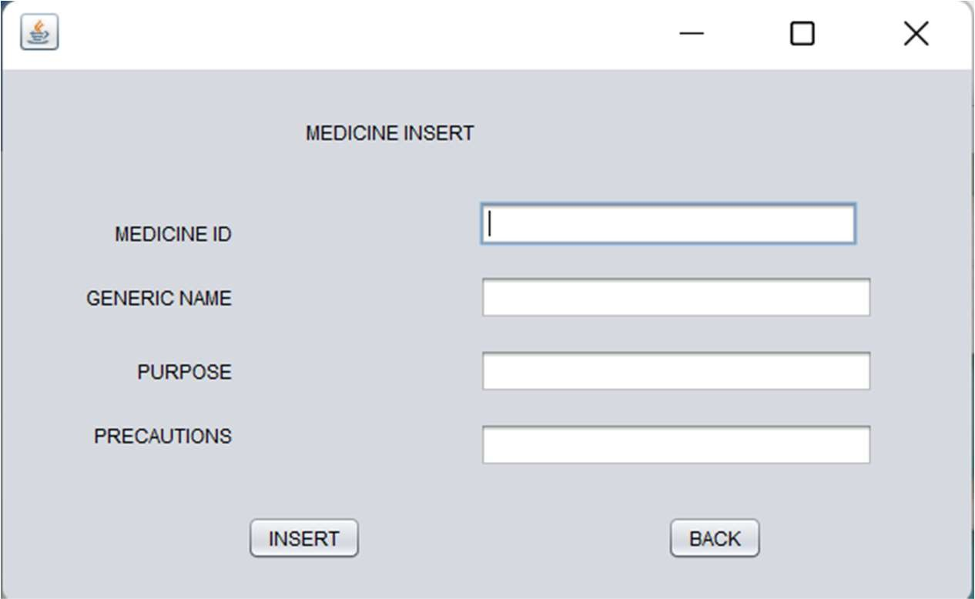


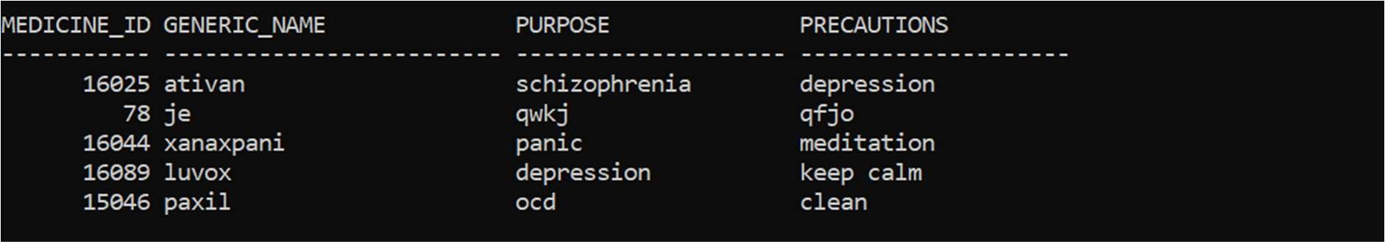

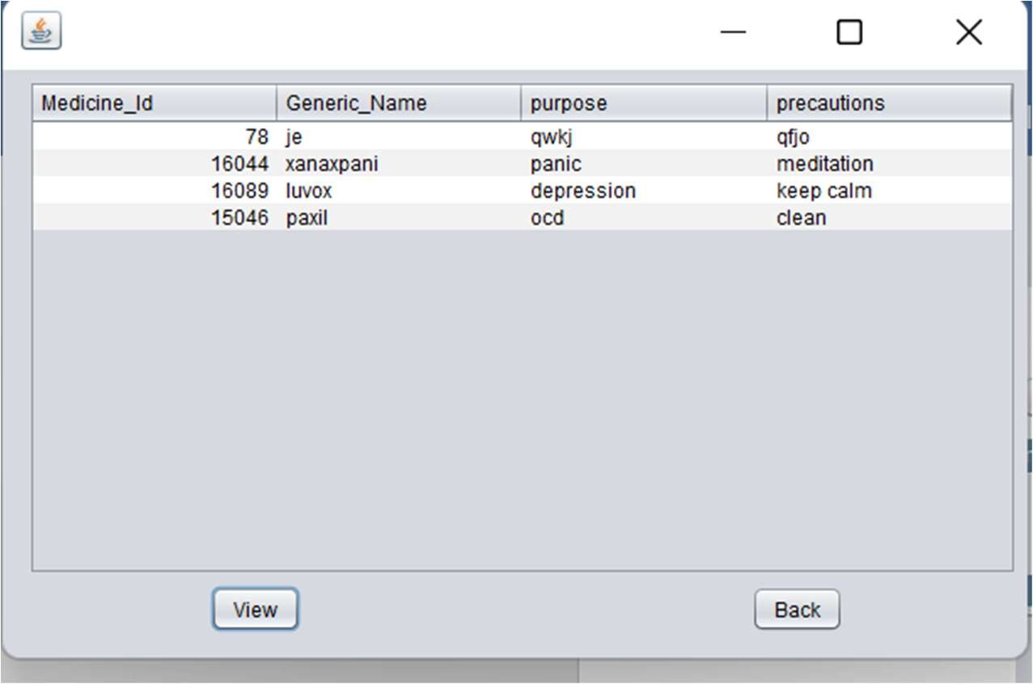

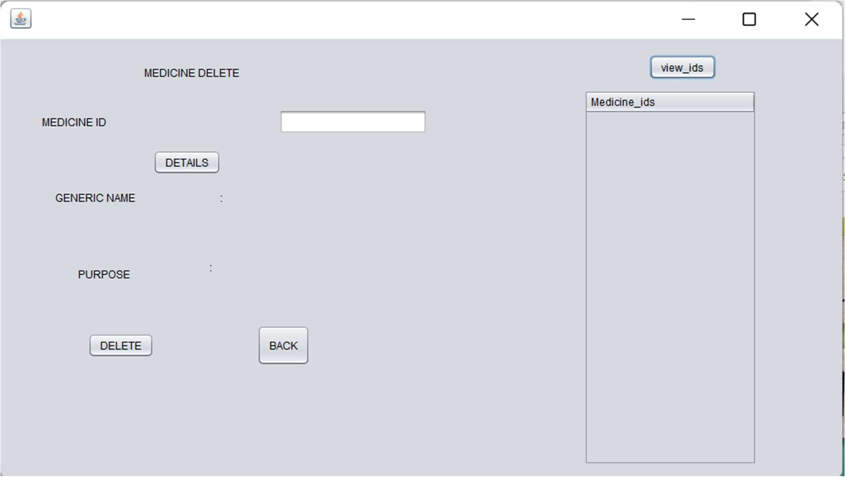

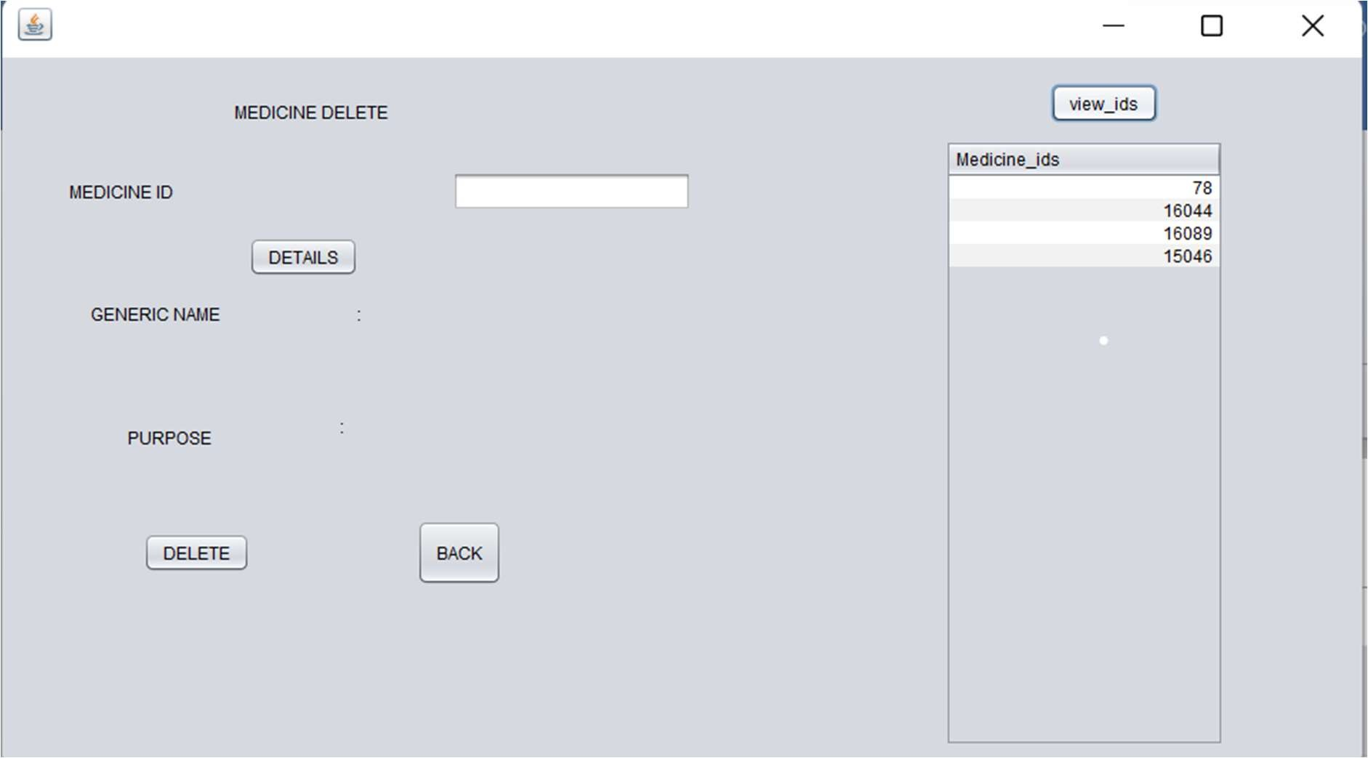

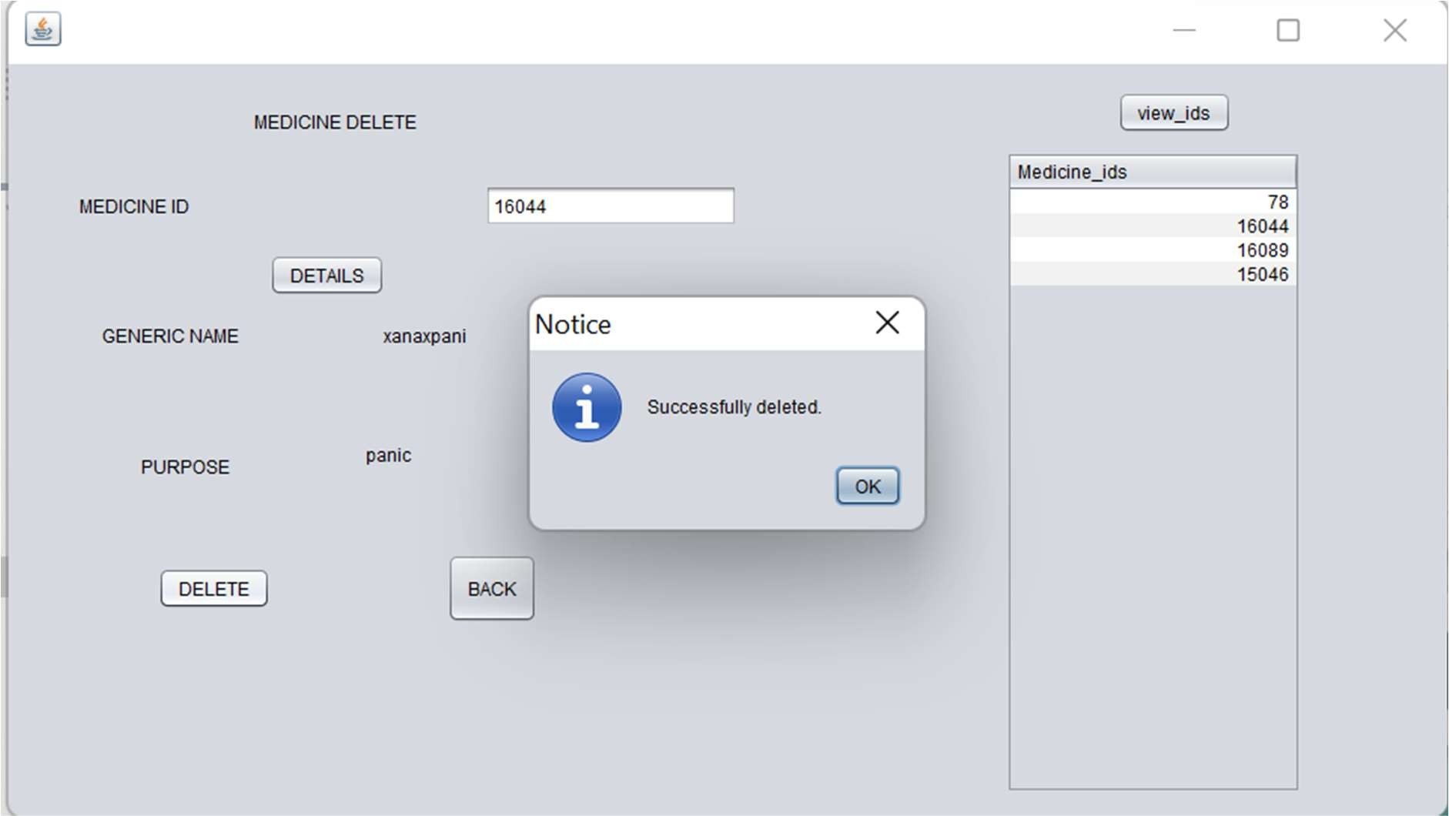

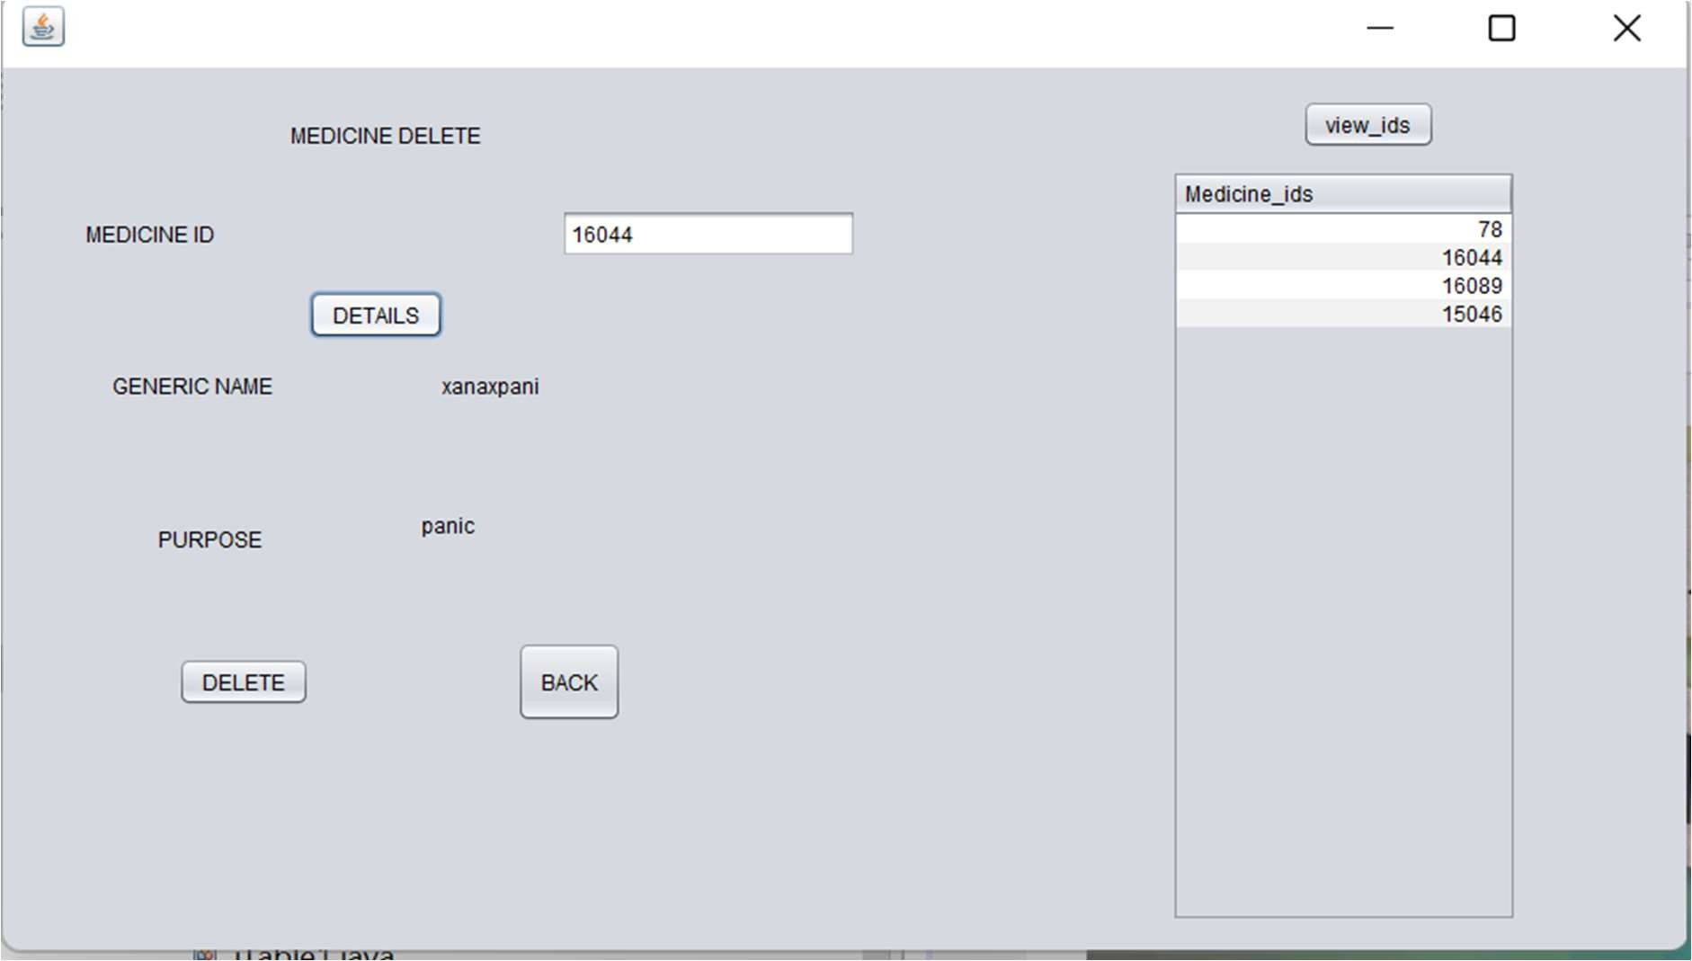

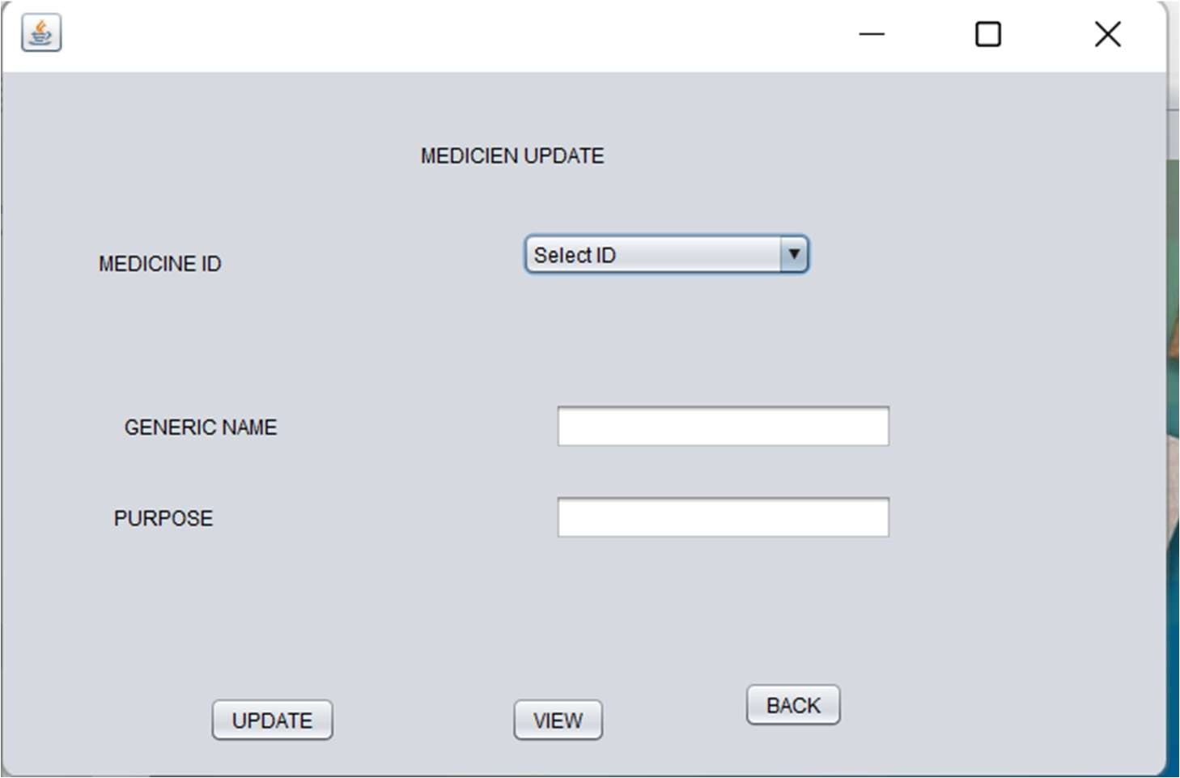

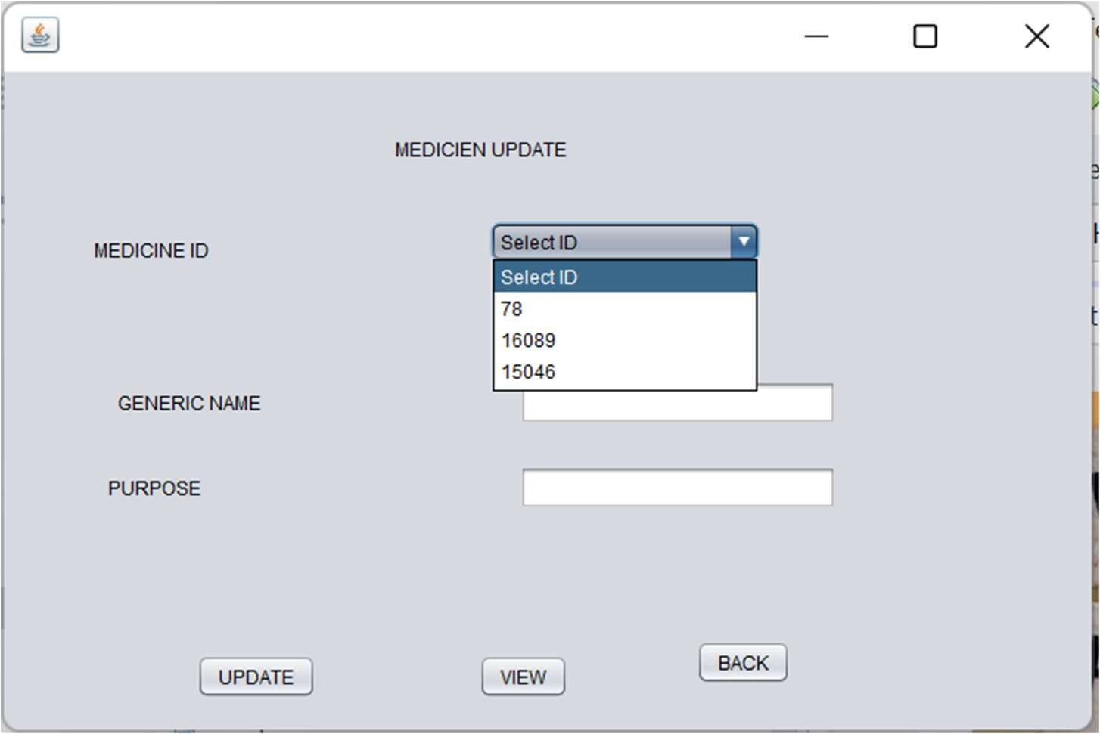

RESULT:
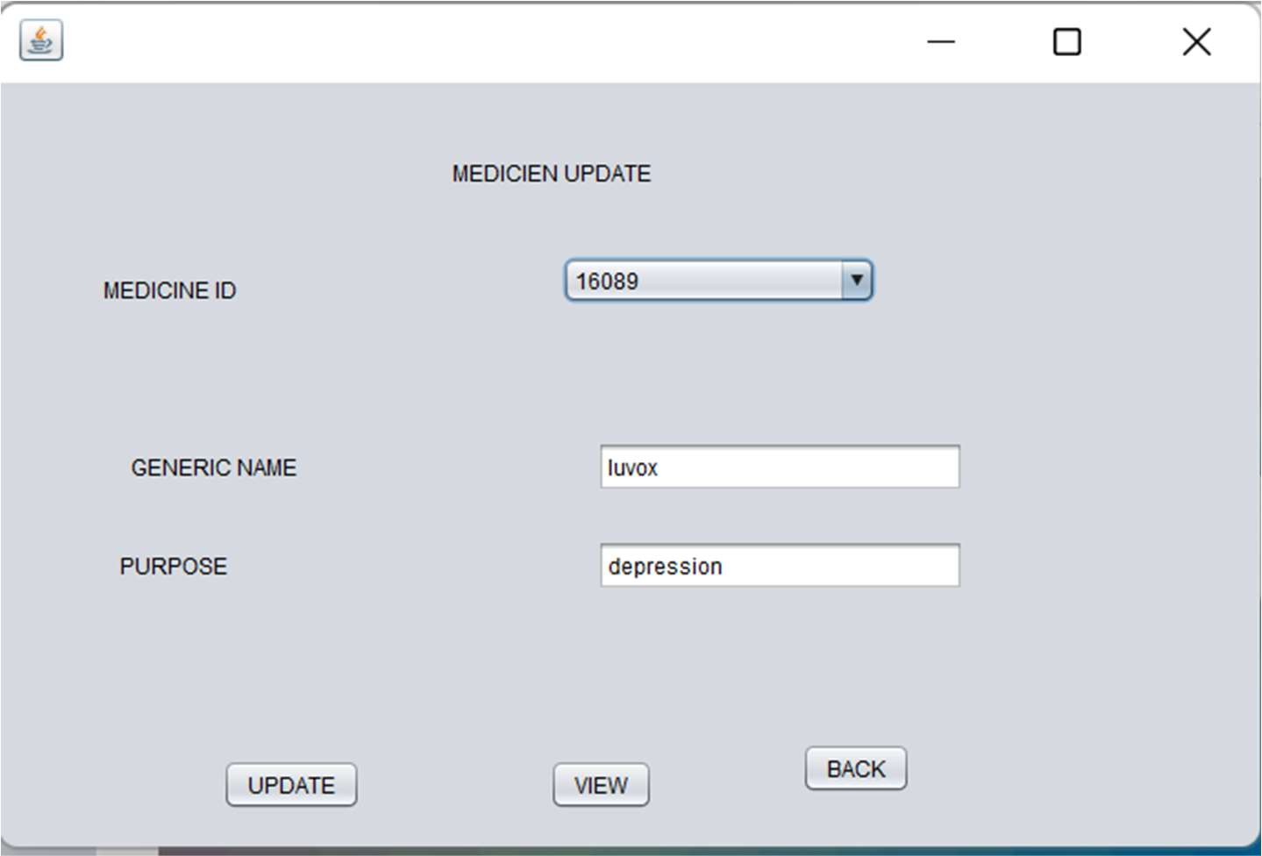
I successfully completed this MINI PROJECT

Discussion and Future work

While doing this project I got new ideas I understood how to work on projects. Now to further extend this project I want to create a android app by which I can control my project on my hand and connect to it.

